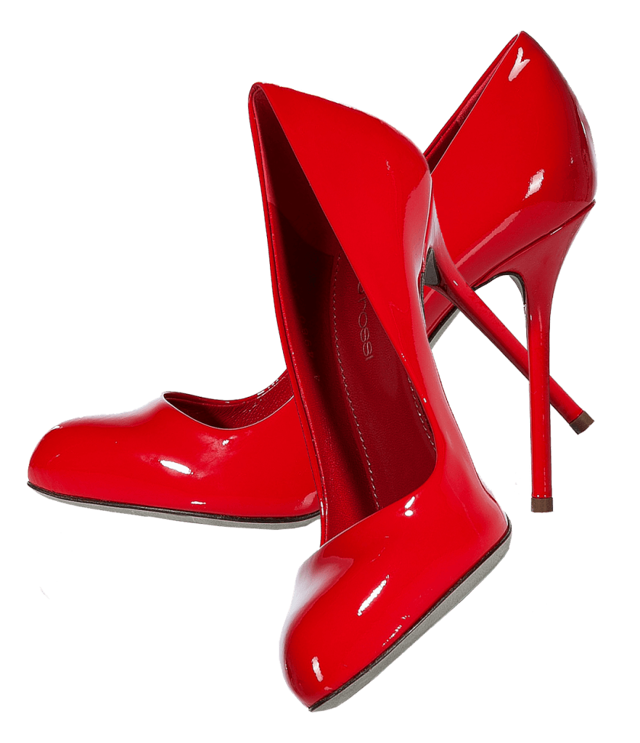

**Upto ~~50 off~~**

**51% OFF**

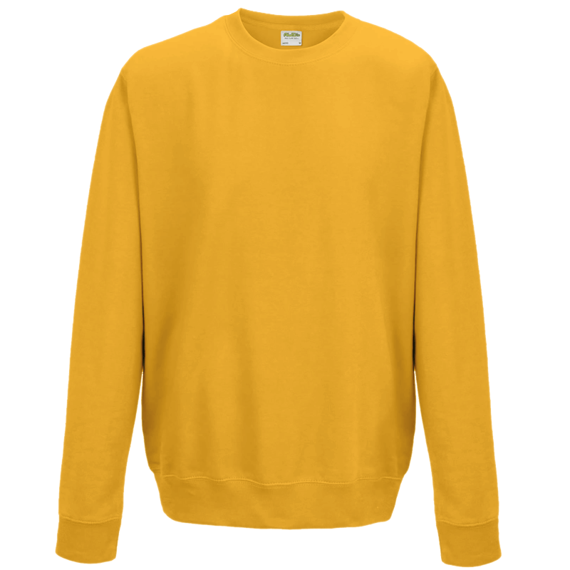

**Free with shoes**